Research Scholar in Residence
Mental Health and Substance Use

Competition

Launch Date:
Initial: March 15, 2022
Extension Announcement: April 19, 2022

Letter of Intent Deadline:
Friday, May 13 at 16:30

Submission Deadline:
Friday, August 19, 2022 at 16:30

Sponsored By: Island Health

Island Health

Scholar in Residence Competition

Table of Contents

1. INTRODUCTION & PURPOSE 3

2. PROJECT SCOPE 6

3. ACCOUNTABILITY 6

4. RESEARCHERQUALIFICATIONS 7

5. DUTIES ANDRESPONSIBILITIES 7

6. PROGRESS REPORTING 7

7. EVALUATION PROCESS 8

8. SCHOLAR IN RESIDENCE COMPETITION SUBMISSION PROCESS & FORMAT 9

9. DEFINITIONS AND GENERAL TERMS AND CONDITIONS 11

Appendix A: Research Scholar in Residence Letter of Intent Template 13

Appendix B: Declaration of Stakeholder Affiliation/Conflict of Interest Template 14

Page | 2

- INTRODUCTION & PURPOSE

1.1 Island Health Mental Health and Substance Use: Population and Service Continuum

MHSU challenges are common. In 2016, more than 7.5 million people, or 1 in 5 Canadians, experienced a mental illness or substance use issue. According to Statistics Canada, the number is higher in British Columbia (BC) at 1 in 4 British Columbians. Further, the percentage of British Columbians reporting positive mental health is trending downwards, with rising rates of mental health conditions across the lifespan (MMHA, 2018). Nationally, MHSU issues are most prevalent among “working age” adults aged 20-49, with 52.3% having an MHSU challenges (Statistics Canada, 2016).

An important factor to consider is the interaction between stigma and mental health challenges, with 40% of British Columbians reporting stigma as preventing them from seeking help for anxiety or depression (MMHA, 2018). These rising rates of MHSU challenges are occurring alongside increasing rates of suicide mortality in Island Health. The Canadian average suicide mortality is 10.3/100,000; the BC average is 11.5/100,000; and Island Health’s is 13.8/100,000 (BC Coroner Services Reporting, 2018; Statistics Canada).

MHSU is also increasingly prevalent among children and youth. The Mental Health Commission of Canada estimates 900,000 adolescents live with a mental illness in Canada in 2016 (MHCC, 2017). In BC, 84,000 children and youth have a diagnosed mental disorder (12.2% of youth aged 4-17), and 68,000 meet the criteria for a substance use disorder (11.1% of youth aged 15-24) (RYC, 2016). In BC, this trend is magnified for female and non-binary school aged youth.

MHSU challenges disproportionately affect Indigenous people. Indigenous peoples experience higher rates of depression, anxiety and mood disorders, as well as suicide ideation, attempts and completion rates (BC Govt, 2020). These trends are borne disproportionately by Indigenous females and non-binary individuals.

Additionally, Indigenous individuals are significantly impacted by the opioid toxicity public health emergency. According to the First Nations Health Authority (FNHA), Indigenous people accounted for 14% of all overdose deaths in 2017 in BC despite comprising only 3.4% of the population (FNHA, 2017). Additionally, Indigenous people are three times more likely to die from an overdose than non-Indigenous people are, and Indigenous females experience an overdose rate that is 10.1 times higher than non-Indigenous females (FNHA, 2017; BC Govt, 2020). Indigenous people also experience more harms related to substance use (McKenzie et al., 2016; Firestone et al., 2015). These experiences are all magnified in relation to the current COVID-19 pandemic, which has disproportionate primary and secondary impacts on First Nations communities, with reports of worsening mental health, higher COVID-positive rates, and increased stress from Isolation. All of this points to the imperative nature of enhancing cultural humility and safety in mental health and substance use services.

The Mental Health and Substance Use (MHSU) service continuum covers a tiered system of care. Island Health MHSU system has traditionally held responsibility for Tiers 3-5 (i.e. core services), and has recently assumed responsibility for Tier 2 as well.
Tier 1 – Mental Health and Wellness Promotion/Problematic Substance Use Prevention

- This tier of service involves tools, education and anti-stigma efforts for the general population around wellness promotion, self-management and self-help and prevention. Also includes

collaboration with policy makers around social determinants of health.

  - Island Health involvement in this tier is as a partner and enabler for primary care, schools, and

community partners to lead service provision.
Tier 2 – Targeted Prevention and Early Intervention

  - Treatment for mental health and substance use problems that cause mild impairment of daily function and mild-moderate disability. Problems can be managed through regular primary care

Page | 3

and community support services; however, individuals may require occasional psychiatric review/consultation and may experience episodic crises.

  - Island Health involvement is to provide review and consultation, as well as support for episodic

crises, and act as a partner to Primary Care services in providing care to clients. Tier 3 – Access, Urgent and Counselling Services

  - Treatment for high prevalence presentations including episodic severe states, without general impairment of everyday functioning. Individuals experience moderate and episodic severe needs. These individuals are generally able to attend to basic living needs and benefit from short-term interventions, counselling/psychotherapy services, and/or redirection to community supports. Individuals are ready, willing and able to engage with service. Rapid response to crisis

presentations and gateway to MHSU Specialized Community Service Programs (SCSP). Tier 4 – Specialized Team-Based Outpatient and Rehabilitation Services

  - Treatment for complex psychiatric illness with or without substance use problems and/or addictions, or co-morbid physical health needs, which are associated with a moderate to severe level of functional disability. Individuals require regular assistance with daily living and require team-based care as they often have multiple service needs, regular care of a psychiatrist, and have experienced multiple hospitalizations. Individuals are generally impaired in their

readiness, willingness, or ability to engage with services.
Tier 5 – Highly Specialized Care

  - Treatment for severe, complex, and often chronically disabling mental illness and substance use problems requiring intensive and highly specialized interventions, acute care assessment, stabilization and care planning, and supported timely transition back to community.

Facts & Figures:

Island Health is governed by a board of directors, appointed by the provincial government. An executive team leads the delivery of health service within the Health Authority. Island Health is publicly funded, and accountable to the provincial government and the public for resources used in delivering health care and services.

The figure below provides summary information regarding the Island Health MHSU program budget and staff across the region

Page | 4

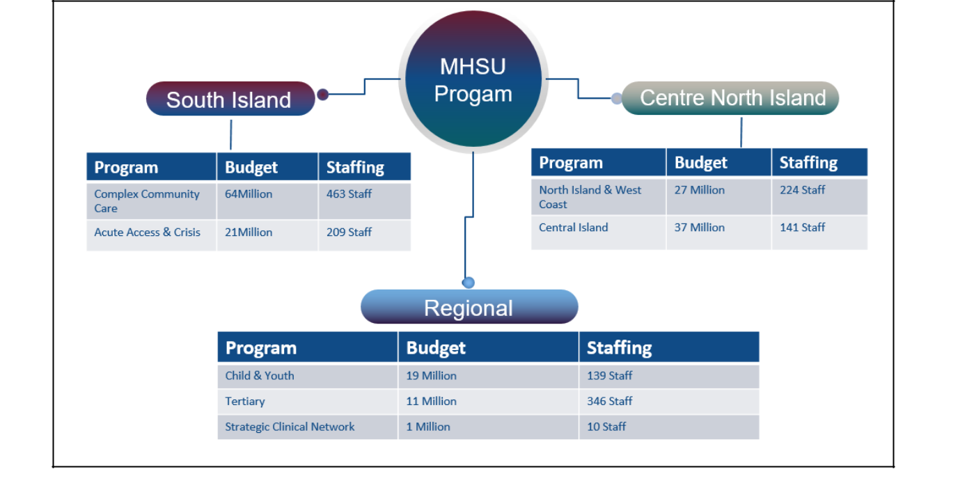

1.2 Purpose

The purpose of this Competition is to identify an appropriately qualified academic researcher to collaborate with Island Health Mental Health and Substance Use Team Members such as health service leaders, physicians and staff to support health-based research, focused on identified strategic priority areas.

Research is an integral enabler of Island Health’s ability to improve the health and quality of life of its residents. Research supports the continued enhancements in health services and the quality of care for patients, ensuring that practice is informed by evidence in an ongoing effort to bridge the research-practice-service gap.

Island Health’s Research Strategy builds on our existing capacity, including strong partnerships and established supports enabling patients, families, health service leaders, physicians, clinicians and researchers to collaborate to improve health outcomes. Our direction is guided by current and future service and health system priorities. With a publically stated mandate of care, education and research, Island Health’s research strategy focuses on evidence-informed practice and policy by building learning health system capacity with closer integration with quality improvement, clinical governance and clinical excellence.

1.3 Summary & Key Dates

Island Health is requesting proposals for a Research Scholar in Residence to foster collaboration with an academic researcher in British Columbia whose institution is supportive of seconding the researcher on a part time basis (approximately 2 days per week) for a total of 2 years with an option for extension at the discretion of Island Health and in consultation with the Scholar in Residence.

Page | 5

Milestone Activity | Deadline
Competition Launch (Extension) | Tuesday, April 19, 2022
Letter of Intent Due | Friday, May 13, 2022 at 16:30
Invitation to Submit a Complete Proposal | Friday, June 3, 2022 at 16:30
Proposal Submission Deadline | Friday, August 19, 2022 at 16:30
Successful Applicant Notified | Friday, September 30, 2022
Scholar in Residence Start Date | January 2023

- PROJECT SCOPE

The Scholar in Residence will work in partnership with the MHSU Program including the Strategic Clinical Network, program operations and/or Executive Leadership. Research activities will align with MHSU

Strategic Plan priorities, outcomes and/or goals (illustrated below) for the MHSU tiered system of care (outlined in section 1.1).
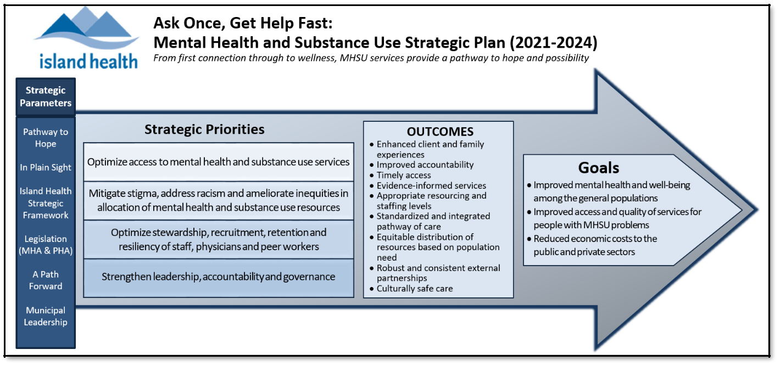

- ACCOUNTABILITY

The Scholar in Residence will be accountable to the Executive Director and the Executive Medical Director for MHSU Regional Strategy, and to the Director, MHSU Strategic Clinical Networks – Quality and Clinical Networks. The Scholar in Residence is required to abide by best practice in indigenous cultural safety and anti-racism, respectful conduct and Island Health Policies.

The Scholar in Residence will collaborate with Island Health regarding any scheduled communications material or public events relating to the research. The Scholar in Residence will acknowledge the support of Island Health on any reports, publications, materials or products generated from or about the research.

Page | 6

- RESEARCHER QUALIFICATIONS

The Scholar in Residence is required to have:

  - A strong academic record in leading health services or population health research and knowledge translation.

  - Full time Institutional title/rank of Professor/Associate/Assistant Professor, Clinical Fellow, or Postdoctoral Fellow.

  - Demonstrated knowledge on the Tri-Council Policy Statement 2, research integrity requirements, equity diversity and inclusion and applicable regulations, such as privacy legislation as it pertains to health research, in BC.

- DUTIES AND RESPONSIBILITIES

Research Activity (Approximately 70%)

- Conduct of Research: Collaborates with Island Health to plan and design research in collaboration with internal and external colleagues. Secures funding for research.

- Knowledge Translation: Collaborates with Island Health and the sponsoring academic institution to disseminate and implement research findings through publications, presentations, delivery applications, and implementation of research evidence into policy and practice. Utilizes knowledge mobilization principles to formulate next generation research questions.

Research Capacity Building & Sustainability (Approximately 30%)

  - Research Collaborations: Builds local, national, and international research collaborations in the identified research area that mutually benefits Island Health and the sponsoring academic institution. Works with Island Health, sponsoring academic institution, and funding agencies (as applicable) to support the initiation of research projects by Island Health, the sponsoring academic institution and community-based organizations.

  - Research Partnerships: Develops effective working relationships on local unit-based clinical, quality and/or research teams to build supports for research and the research environment within Island Health.

  - Research Mentoring: Provides research mentoring for Island Health staff related to the research program, community engagement and knowledge translation. Participates in communities of practice, periodic educational workshops and other forums to promote and support research awareness and skills development.

  - Research Environment: Fosters a research environment by generating supports and opportunities to identify research questions from front-line staff or patients, families or community members relevant to the research program, locate and critique research evidence and selectively evaluate and apply evidence to decision-making, practice and the practice environment when related to the research program.

- PROGRESS REPORTING

  - Upon assuming the role, the Scholar in Residence will refine the project plan in conjunction with the Collaborating Leads at Island Health outlining: 1) the scope of planned activities, 2)

Page | 7

specific deliverables, 3) project timelines and milestones.

  - A quarterly progress report will be provided to the Collaborating leader at Island Health and the Executive leads of the program area and the Director, Research.

  - The project plan may be amended or revised over the two-year term, as required.

- EVALUATION PROCESS

Review of the Letters of Intent will comprise a preliminary assessment of the alignment of the proposed program of research with organizational priorities and researcher qualifications. An invitation to submit a complete proposal will be provided to selected applicants.

Full proposals will be reviewed and scored based upon the criteria outlined below. Island Health reserves the right to invite one or more applicants to attend an interview (or participate in a teleconference), provide a presentation, and/or to provide written clarification of their response(s).

Evaluation Criteria |  | Points
1. Researcher Qualifications & Experience |  | 40 points total
Qualifications, experience and past accomplishments relevant to the Scholar in
Residence scope of activities; similar research projects and collaboration with health |  | [25] points
service providers
Record of publication |  | [10] points
Record of securing research funding |  | [5] points
2. | Alignment with MHSU priority(ies) areas | 40 Points Total
Alignment of planned research with MHSU Strategic Priorities, Outcomes and Goals. |  | [20] points
Potential benefit of research, knowledge translation/mobilization and mentoring |  | [20] points
activities
3. | Scientific rigor, merit and feasibility of the proposed strategy | 30 points total
Proposed research focus and/or activities justified through literature
summary/synthesis, research questions/hypothesis outlined, and utilization of broad |  | [15] points
knowledge translation/mobilization strategies
Research capacity building & sustainability activities aligned with requirements |  | [15] points
of this competition
4. Budget Alignment, Time Commitment and Academic Institutional Support |  | 15 Points total
Institutional support of secondment arrangement for the applicant |  | [5] points
FTE equivalency/number days per week committed to implement research activities is |  | [10 points]
aligned with the available budget

Page | 8

- SCHOLAR IN RESIDENCE COMPETITION SUBMISSION PROCESS & FORMAT

8.1 Mandatory Criteria

Proposals not clearly meeting submission deadlines or mandatory criteria will be excluded from further consideration during the evaluation process. All applicants should exercise extreme care as failure to comply with the requirements of this Competition may cause a Proposal to be rejected.

8.2 Submission of Letter of Intent by: Friday, May 13, 2022 at 16:30

Applicants must complete and return the Letter of Intent form by 16:30 (4:30 pm PST) (See Appendix A of this document: Research Scholar in Residence Letter of Intent Template).

Selected applicants will be provided with an invitation, via email, to submit a complete proposal. Applicants must complete and return the Proposal with required content and format outlined below.

8.3 Submission of Complete Proposal by: Friday, June 3, 2022 at 16:30

8.3.2 Proposal Submission Format and Content Criteria

Format:

All submissions are to be in PDF format.

The file name should be identified by the Applicants Surname: e.g. Moore_coverletter.pdf All materials, except appendices:

- Must be a minimum 11 point size in standard font, single spaced, on one side of a letter-sized (21.25 x 27.5 cm / 8.5” x 11”) page, with a one-inch margin on all sides of the page.

- Should be consecutively numbered and have a header with the proposal name on the top left-hand corner, and footer with the page number on the lower right-hand corner of each page.

Content:

- A competition cover page outlining: Name, Position, Contact information (phone number and email), University, and Department.

- Research Scholar in Residence Proposal - Up to eight pages.

o Activities: Describe the scope of the proposed / planned research focus / activities justified through literature summary/ synthesis, and how they align with a priority area(s). As far as is possible, include the problems or knowledge gaps to be addressed, and proposed research question(s) / hypothesis, aims of the project(s), anticipated methodology(ies), number of studies, anticipated outcomes, potential impacts, knowledge translation/mobilization strategies, and capacity building/mentoring & sustainability activities.

o Potential Granting Opportunities: List the potential grant application opportunities that may be pursued that are associated with the planned research activities.

o Potential Partnership Opportunities: Describe any additional opportunities for partnership with patients/families, the public, community providers, indigenous peoples and communities, academic institution or other groups that may arise from the research.

Page | 9

  - Budget: Island Health has allocated a total of CAD $67,500.00 per year for two (2) years, or CAD $135,000 total, inclusive of salary, benefits and direct costs to support the Scholar in Residence role, payable to the University. Please include the projected number of days per week that would be allocated to this role per semester based on direct compensation for salary/benefits. Costs must align with Island Health finance and travel policies. Indirect costs are an ineligible expense.

- Appendices

Appendix 1: Qualifications & Experience of the Applicant

- A one (1) page summary of the applicant’s experience and past accomplishments relevant to the Scholar in Residence scope of activities, similar research projects and collaboration with Health Authority or health service providers.

- Applicant’s CV which should include: Education; Licenses & Certifications; Professional Affiliations; Presentations; Other knowledge translation/mobilization activities; Research collaboration/partnership activities; Research mentoring activities

Appendix 2: Academic Institutional Support Letter

Provide a letter from the sponsoring academic institution indicating:

- Alignment of the Scholar in Residence role with their institutional goals/objectives.

- Confirmation that the budget for this part-time role is acceptable.

- Institutional commitment to a secondment agreement.

Signatories to letter of support are to include:

- The VP of Research (or equivalent)

- Department Chair/Director

- Research Administration – Dean or Chair

Appendix 3: Declaration of Stakeholder Affiliation/Conflict of Interest (See Appendix B of this document for template to be utilized)

Contact Person

For information related to this Competition and to submit related documents, please contact:

Tracey Nigro, PhD, RN, RPsych (#1811)

Director, MHSU Strategic Clinical Network - Quality and Clinical Networks Island Health

#622 – Eric Martin Pavilion

2328 Trent St Victoria, B.C. V8R 4Z3
250-812-0061

Tracey.Nigro@islandhealth.ca

Page |

- DEFINITIONS AND GENERAL TERMS AND CONDITIONS

- Definitions: Throughout this document, the following definitions apply:

- “Contact Person” means the Island Health Contact person for any communication in respect of this Competition, as identified herein or in any addenda to this Competition issued by Island Health;

- “Contract” means the written agreement resulting from this Competition, executed by Island Health and any selected Applicant(s);

- “Island Health” means Vancouver Island Health Authority;

- “must”, or “mandatory” means a requirement that must be met in order for a Proposal to receive consideration;

- “Applicant” means entity that submits a Proposal;

- “Proposal” means all of the documentation submitted by in response to this Competition, which has been accepted by Island Health;

- “Competition” means this Scholar in Residence Competition issued by Island Health for the goods and/or services specified in this document, and any addenda to this document issued by Island Health;

- “should” or “desirable” indicates a requirement that Island Health would like the

Applicant to address in its Proposal;

- “Submission Deadline” means the time on the date set out in this document by which a prospective Applicant must submit the Proposal, as may be amended; and

- Invitation. This Competition is an invitation for a prospective Applicant to submit a Proposal. Island Health is not bound to enter into a Contract with any Applicant and Island Health may at its sole discretion,

cancel its decision to enter into a Contract with a selected Applicant at any time until

such time that a Contract is entered into by Island Health and the Applicant.

- Acceptance. Submission of a Proposal indicates acceptance by the Applicant of all the terms of this Competition, including the terms of any addenda to this Competition issued by Island Health.

- Eligibility. Proposals will not be evaluated if the current or past interests of the Applicant may, in Island Health’s opinion, give rise to a conflict of interest in connection with the goods or services described in this Competition - this includes, but is not limited to, involvement by an Applicant in the preparation of this Competition. If an Applicant is in doubt as to whether there might be a conflict of interest, the Applicant should consult with the Contact Person. In addition, the Applicant must complete the Conflict of Interest Declaration, in the form attached (Appendix B), as part of the Proposal if the Applicant believes they might be in a conflict of interest.

- Letter of Intent. Applicants must submit the attached Letter of Intent Form.

- Submission of Proposals.

- Submission Deadline. Proposals must be submitted by the Submission Deadline to the Contact Person. Late Proposals will not be accepted.

- Amendment / Withdrawal of Proposal. By submission of a clear and detailed written notice to the Contact Person, the Applicant may amend or withdraw its Proposal prior to Submission Deadline. Any amendment or notice must be submitted in the same manner as prescribed in this Competition for the

Page | 11

submission of Proposals. As at the Submission Deadline, all Proposal submitted become irrevocable and the Applicant may not thereafter amend its Proposal.

- Proposal Clarification. Island Health reserves the right to seek clarification or supplementary information from an Applicant after the Submission Deadline. Any response received by Island Health from the Applicant shall, if accepted by Island Health, form an integral part of that Applicant’s

Proposal.

- Ownership of Proposals. All Proposals and any accompanying documentation submitted to Island Health become the property of Island Health and Island Health is not required to return the Proposal or such documentation to the Applicant.

- Evaluation.

- Evaluation Committee. Evaluation of Proposals will be by a committee designated by Island Health and may include employees and contractors of Island Health or other third parties in Island Health’s sole discretion.

- Contract.

- Selection of Applicant. Island Health anticipates that one Applicant will be selected by Island Health. The selected Applicant’s

Academic Institution shall enter into discussions with Island Health with a view to concluding Secondment Agreement.

- Applicant Expenses: Applicants are solely responsible for their own expenses in preparing a Proposal, and for subsequent due diligence and negotiations with Island Health, if any. Island Health shall not be liable for any expenses, costs, losses, or damages incurred or suffered by an Applicant or any third party resolution from Island Health exercising any of its rights under this Competition.

Except as otherwise expressly set out in Section 9, Island Health shall not be liable to pay any costs or expenses of any Applicant whatsoever.

- No Claim by Applicant or Third Parties.

- FOIPPA. The Proposal and documents provided may be released in accordance with the Freedom of Information and Protection of Privacy Act (British Columbia), as maybe amended. An Applicant should identify any information in its Proposal or any accompanying documentation for which confidentiality is to be maintained by Island Health.

Page | 12

Appendix A: Research Scholar in Residence Letter of Intent Template

Mental Health and Substance Use - Island Health

Submission Deadline: Friday, May 13, 2022 at 16:30

Name:

Phone: Email:

Title:
University:
Department:
MHSU Strategic Priorities, Outcomes and Goals addressed:

Summary of Proposed Research Project(s):

Page | 13

Appendix B: Declaration of Stakeholder Affiliation/Conflict of Interest Template

Capitalized terms used in this Conflict of Interest Declaration (“Conflict Declaration”) shall have the meaning ascribed thereto in the Scholar in Residence Competition of which this declaration forms a part. Island Health requires that each Applicant, if they believe they are in a conflict of interest, to complete this Conflict Declaration as part of its Proposal in accordance with the Scholar in Residence Competition.

Instructions

The purpose of this conflict of interest declaration is to advise Island Health of any Conflict of Interest the Applicant may have in respect to the Scholar in Residence role at Island Health. Upon the disclosure of a Conflict of Interest, Island Health will make a decision as to whether it should disqualify an Applicant.

Accordingly, full disclosure as to any Conflict of Interest by each Applicant is required. The accurate disclosure of a Conflict of Interest will result in an analysis by Island Health, where the failure to disclose a Conflict of Interest may result in immediate disqualification.

- “Conflict of Interest” shall be defined as any situation or circumstance where, in relation to this Competition process, the Applicant has an unfair advantage or engages in conduct, directly or indirectly, that may give it an unfair advantage, including (i) possessing or having access to information in the preparation of its Proposal that is confidential to Island Health and is not available to other Applicants; (ii) communicating with any official or representative of Island Health or members of the Evaluation Committee with a view to influencing them and obtaining preferred treatment in this Competition process; or (iii) engaging in conduct that compromises or could be seen to compromise the integrity of the open and competitive Competition process.

2. Conflict of Interest Declaration

I, (Name of the Applicant) have carefully reviewed my own situation and/or that of the

institution which I represent and declare as follows:

- I have no conflict of interest to declare,

OR

I am involved in some situations or actions that might be regarded as a potential Conflict of Interest. Details of

each of these situations and/or actions are as follows:
1. |  | _
2.
3. |  | _

I agree to notify Island Health immediately if any situations or actions develop that might be regarded as a potential Conflict of Interest in respect of this Competition process. I hereby declare of the contents of this
Statement of Full Disclosure and Conflict Of Interest Declaration to be true and correct.

Signature: |  |  | Dated this | _ day of |  |  | , 2022
Name of Applicant (please print):
 |  |  |  |  |  |  |  | Page | 14

