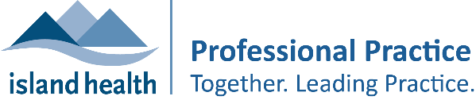
Learning Plan for:
Prepared by:
Date:

Complete this table using SMART goals.
S – Specific: Specify a single measurable result or outcome to be accomplished.
M – Measurable: Measurements to gauge results such as quality, quantity, time and effectiveness.
A – Attainable: Must be attainable and consider scope, experience, and operational resources available.
R – Relevant: Goal must be directly related to role and responsibility of employee.
T – Trackable: Goal must be trackable and verifiable.

Goal #1
What do I want to learn? | How does this relate to my practice? | How am I going to achieve my learning? | What resources will I require? | When will I achieve my learning? | How will I evaluate and track my learning?
Goal #2
What do I want to learn? | How does this relate to my practice? | How am I going to achieve my learning? | What resources will I require? | When will I achieve my learning? | How will I evaluate and track my learning?
Goal #3
What do I want to learn? | How does this relate to my practice? | How am I going to achieve my learning? | What resources will I require? | When will I achieve my learning? | How will I evaluate and track my learning?

