**Handwashing**

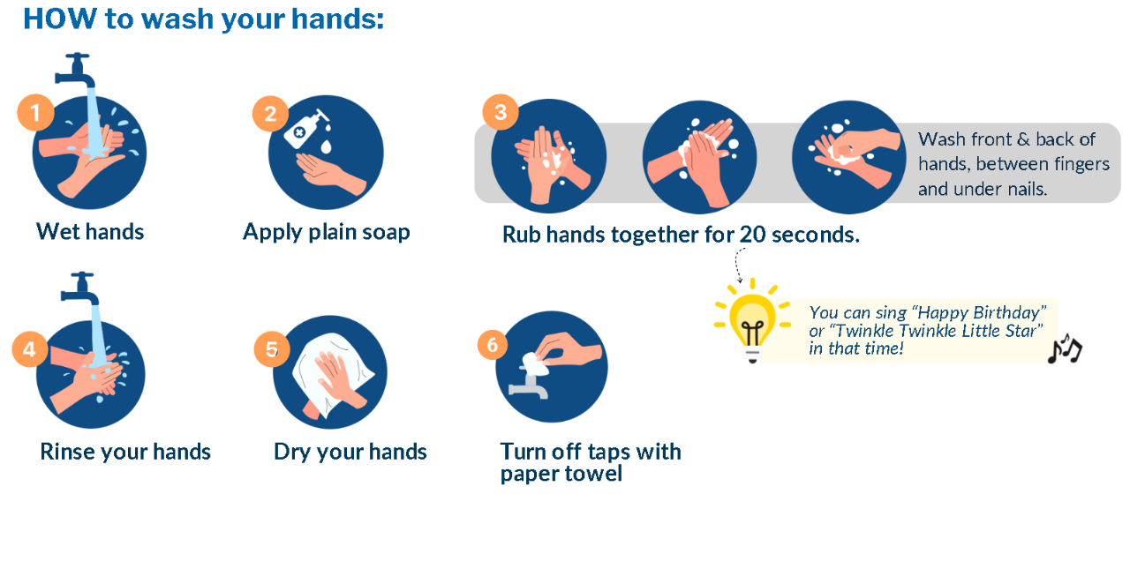Germs spread easily in a classroom. Washing your hands is the best way to stop germs that cause colds, the flu, diarrhea and other illnesses. It is important for kids to learn how and when to wash their hands to help them stay healthy.

**When to Wash Hands**:

* Before and after handling food and eating
* After using the toilet
* After coughing, sneezing, or blowing your nose
* After touching pets or animals
* After cleaning up after animals
* After touching garbage
* When your hands look dirty or feel greasy

For more information:

* Island Health - visit the Healthy Schools webpage or contact Public Health
* HealthLink BC - [Hand washing: Help stop the spread of germs](https://www.healthlinkbc.ca/healthlinkbc-files/hand-washing-help-stop-spread-germs)
* BCCDC - [Hand Hygiene](http://www.bccdc.ca/health-info/prevention-public-health/hand-hygiene)